UI/UX ADAPTATION VIA FACE EMOTION RECOGNITON

MINOR PROJECT REPORT

Submitted in partial fulfillment of the requirement for the Degree of Bachelors of Engineering in Computer Science & Engineering

Submitted To:



PARUL UNIVERSITY, VADODARA, GUJARAT (INDIA)

Submitted By:
DIVYA CHAUDHARY (2303051240072)
SACHIN SINGH (2303051240357)
SHUBHAM SHARMA (2303051240325)

Under The Guidance of:
Dr. Bijal Jigar Talati (ASSOCIATE PROFESSOR, CSE)

DEPARTMENT OF COMPUTER SCIENCE & ENGINEERING PARUL INSTITUTE OF TECHNOLOGY VADODARA, GUJARAT SESSION: AY 2025-2026

Parul University
Parul Institute of Technology



(Session: 2024 -2025)

DEPARTMENT OF COMPUTER SCIENCE & ENGINEERING

CERTIFICATE

This is to certify that Divya Chaudhary, Sachin Singh and Shubham Sharma Students of CSE VI Semester of “ Parul Institute of Technology, Vadodara” has completed their Minor Project titled “UI/UX Adaptation via Face Emotion Recognition”, as per the syllabus and has submitted a satisfactory report on this project as a partial fulfillment towards the award of degree of Bachelor of Technology in Computer Science and Engineering under Parul University, Vadodara, Gujarat (India).

Dr. Bijal Jigar Talati Prof. Sumitra Menaria Dr. Swapnil Parikh
Project Guide Head (CSE) Principal
Associate Prof. (CSE) PIT, Vadodara PIT,Vadodara

DECLARATION

We the undersigned solemnly declare that the project report “UI/UX Adaptation via Face Emotion Recognition” is based on my own work carried out during the course of our study under the supervision of Dr. Bijal Jigar Talati, Associate Professor, CSE.

We assert the statements made and conclusions drawn are the outcomes of my own work. I further certify that
- The work contained in the report is original and has been done by us under the general supervision of our supervisor.
- The work has not been submitted to any other Institution for any other degree / diploma / certificate in this university or any other University of India or abroad.
- We have followed the guidelines provided by the university in writing the report.

Whenever we have used materials (data, theoretical analysis, and text) from other sources, we have given due credit to them in the text of the report and giving their details in the references.

DIVYA CHAUDHARY [2303051240072]
SACHIN SINGH [2303051240357]
SHUBHAM SHARMA [2303051240325]

ACKNOWLEDGEMENT

In this semester, we have completed our project on “UI/UX Adaptation via Face Emotion Recognition”. During this time, all the group members collaboratively worked on the project and learnt about the industry standards that how projects are being developed in IT Companies. We also understood the importance of teamwork while creating a project and got to learn the new technologies on which we are going to work in near future.

We gratefully acknowledge for the assistance, cooperation guidance and clarification provided by “Dr. Bijal Jigar Talati” during the development of our project. We would also like to thank our Head of Department “Prof. Sumitr Menaria” and our Principal “Dr. Swapnil Parikh” Sir for giving us an opportunity to develop this project. Their continuous motivation and guidance helped us overcome the different obstacles for completing the Project.

We perceive this as an opportunity and a big milestone in our career development. We will strive to use gained skills and knowledge in our best possible way and we will work to improve them.

DIVYA CHAUDHARY [2303051240072]
SACHIN SINGH [2303051240357]
SHUBHAM SHARMA [2303051240325]

LIST OF FIGURES

S. No. | Figure No. | Name of Figure | Pag No.
1 | Fig. 3.4.1.1 | User Interface | 10
2 | Fig. 3.4.2.1 | Face Recognition | 11
3 | Fig. 3.4.3.1 | Emotion Recognition | 11
4 | Fig 3.4.4.1 | UI Focused | 12
5 | Fig 3.4.4.2 | UI Stressed | 12
6 | Fig 3.4.5.1 | Backend Processing | 13
7 | Fig 3.4.6.1 | Dashboard Module | 14
8 | Fig 3.5.1 | Use Case Diagram | 15
9 | Fig 3.5.2 | E-R Diagram | 16
10 | Fig 3.5.3 | Data Flow Diagram | 17

LIST OF ABBREVIATIONS

S. No. | Abbreviation | Full Form
1 | UI/UX | User Interface / User Experience
2 | CNN | Convolutional Neural Networks
3 | FER | Facial Emotion Recognition
4 | OpenCV | Open Computer Vision
5 | API | Application Programming Interface
6 | PIL | Python Imaging Library
7 | CSS | Cascading Style Sheets
8 | ER | Entity Relationship
9 | IDE | Integrated Development Environment
10 | HTML | Hyper Text Mark Up Language
11 | GB | Gigabyte
12 | SSD | Solid State Drive
13 | DFD | Data Flow Diagram

ABSTRACT

With the rapid growth of online education, e-learning platforms have become an important part of modern education systems. However, most existing platforms provide the same interface to all users without considering their emotional state.

Students often experience emotions such as boredom, confusion, stress, or frustration while learning. These emotions can significantly affect concentration and learning performance.

This project proposes a system called UI/UX Adaptation via Face Emotion Recognition, which detects user emotions using facial expressions captured through a webcam. The system uses computer vision and deep learning techniques to classify emotions such as happy, neutral, bored, and confused.

Based on the detected emotion, the system dynamically adapts the user interface of the learning platform. For example, if a student appears confused, additional hints may be provided, while bored students may receive interactive content.

The system integrates technologies such as OpenCV, Convolutional Neural Networks (CNN),Deep-Face, Python, Flask, and React.js to create an intelligent and adaptive learning environment.

TABLE OF CONTENTS

FIRST PAGE | I
ABSTRACT | II
ACKNOWLEDGEMENT | III
CERTIFICATE | IV
DECLARATION | V
INDEX | VI
LIST OF ABBREVIATIONS | VII
LIST OF FIGURES | VIII

INDEX

CHAPTER | TOPIC | PAGE NO.
Chapter I | INTRODUCTION
1.1 | Overview
1.2 | Problem Statement
1.3 | Objective of Project
1.4 | Applications or Scope
1.5 | Organization of Report
Chapter II | LITERATURE SURVEY
Chapter III | METHODOLOGY
3.1 | Background / Overview of Methodology
3.2 | Project Platforms used in Project
3.3 | Proposed Methodology
3.4 | Project Modules
3.5 | Diagrams (ER, Use Case DFD, etc.)
Chapter IV | SYSTEM REQUIREMENTS
4.1 | Software Requirements
4.2 | Hardware Requirements
Chapter V | EXPECTED OUTCOMES
Chapter VI | CONCLUSION & FUTURE SCOPE
6.1 | Conclusion
6.2 | Future Work
Chapter VII | REFERENCES

CHAPTER I

INTRODUCTION

Overview
The majority of e-learning platforms give every user the same experience. However, learning outcomes are directly impacted by emotional states.
This project combines adaptive user interface design with facial emotion recognition. Using a webcam, the system takes pictures of people's faces, processes them using deep learning models, and recognizes emotions. The interface dynamically changes as a result.
.

Problem Statement
In the current digital landscape, Students frequently become distracted and lose motivation, while studying from online platforms also the majority of e-learning platforms in the current digital learning environment do not take learners' emotional states into account. Regardless of their level of engagement, confusion, or frustration, users are given a static and uniform interface, no real-time feedback from the system, so students are left to handle their own learning comprehension. Poor personalization and reduced learning effectiveness result from this lack of emotional awareness. Our idea is of to proposed An intelligent system that can recognize user emotions in real time and dynamically modify the user interface in response is desperately needed. The system can offer a more tailored, responsive, and interesting learning experience by combining facial emotion recognition with adaptive user interface mechanisms.

Objectives of the Project

The primary objectives of the project include:
    - Real-Time Emotion Detection: Creating a system that uses webcam-captured facial expressions to identify user emotions in real time.
    - Adaptive User Interface: Creating a dynamic user interface that modifies interaction style, content, and degree of difficulty according to the identified emotional state.

    - Personalized Learning Experience: Increasing user involvement by offering tailored answers, such as tips, interactive features.

    - Emotion Analytics & Tracking: Gathering information about learning behavior and performance by tracking and evaluating user emotions over time.

Applications or Scope:
    - Emotion-Aware E-Learning: Enhances online learning platforms by adapting content and interface based on student emotions to improve engagement and understanding.
    - Human-Computer Interaction & Other Domains: Can be applied in areas such as interactive tutoring systems, gaming applications, and advanced human-computer interaction systems.
    - Behavioral Analytics: Analysis of user emotions over time to understand learning patterns, engagement levels, and overall performance.
    - User Experience Optimization: Improves human-computer interaction.

Organization of the Report
The development and working of the UI/UX Adaptation via Face Emotion Recognition system are explained in this project report, which is divided into multiple sections.
The report begins with the Abstract, providing a brief overview of the system and its objective of enhancing the learning experience through emotion-based UI adaptation. This is followed by the Introduction, which discusses the background, motivation, and the need for an intelligent system that can recognize user emotions and personalize the learning interface.

The System Overview section describes the key components of the platform, including the Emotion Detection Module, which identifies user emotions using facial expressions, and the Adaptive UI Module, which modifies the interface based on the detected emotional state.
The Problem Statement highlights the limitations of traditional e-learning systems that fail to consider user emotions, leading to reduced engagement and effectiveness. The Objectives section outlines the key goals of the project, such as real-time emotion detection, adaptive interface design, and personalized learning experience.
The Methodology section explains the working process of the system, including webcam- based image capture, face detection using OpenCV, emotion classification using CNN, Deep-Face and UI adaptation using predefined rules. It also describes the technology stack used, including Python, Flask, React.js, and deep learning frameworks.
The System Design section presents the structural design of the system using diagrams such as Data Flow Diagrams (DFDs), Use Case Diagrams, and architecture diagrams to illustrate system interactions and data flow.
Finally, the Implementation section describes the technical development of the system, including frontend-backend integration, real-time emotion processing, and deployment of the machine learning model within the application.

CHAPTER II

LITERATURE SURVEY

Purpose: To review existing research, tools, and techniques related to facial emotion recognition, adaptive user interfaces, and intelligent e-learning systems, and to identify gaps in current platforms to support the development of an UI/UX emotion-aware adaptive learning system.

Background: Why Visual Reasoning Systems Matter

Effective learning is not only dependent on content delivery but also on the emotional state of the learner. Traditional digital learning platforms operate without awareness of user emotions, providing the same interface regardless of engagement, confusion, or stress.
An intelligent system that integrates emotion detection with UI adaptation can bridge this gap by understanding user behavior in real time and adjusting the learning experience accordingly.

Major Categories of Visual Analysis Approaches

Based on how systems detect and respond to user emotions, existing approaches can be categorized into the following types:

Rule-Based Learning Systems:
These systems rely on predefined logic such as quiz scores or user activity to adapt content. While useful, they do not consider emotional feedback and often fail to detect disengagement.

Facial Emotion Recognition Systems:
These systems use computer vision techniques to analyze facial expressions and detect emotions. Early approaches relied on manual feature extraction, while modern systems use deep learning models like CNN for higher accuracy.

Machine Learning & Deep Learning Models:
Advanced systems use CNN and other neural networks trained on datasets like FER2013 and CK+ to automatically extract facial features and classify emotions in real time.

Real-Time Emotion-Aware Systems:
These systems continuously monitor user emotions through webcam input and dynamically adapt the interface. They represent the most advanced category but are still limited in practical implementation.

Tools and Technologies

The system uses various tools and technologies to enable emotion detection and UI adaptation.
    - OpenCV: Used for real-time face detection and image processing.

    - Deep Learning Frameworks (TensorFlow/PyTorch): Used to build and train CNN models for emotion classification.
    - Web Technologies (React.js, HTML, CSS): Used to develop a dynamic and responsive user interface.
    - Backend Framework (Flask): Handles communication between frontend and machine learning modules.
These technologies work together to create a real-time, intelligent, and scalable system.

Evaluation Metrics
- Emotion Detection Accuracy: Measures how accurately the system identifies user emotions.
- Response Time: Evaluates how quickly the system detects emotions and updates the UI.
- User Engagement Level: Assesses improvement in user interaction and learning effectiveness.

Challenges Identified
The challenges in existing systems are that most platforms do not consider user emotions, no dynamic adaptation , difficulty in handling continuous emotion detection, systems do not learn user behavior over time, multimodal systems (face, speech, physiology) improve accuracy but require complex setups and higher computational resources, making them less practical for simple applications, techniques like deep learning and reinforcement learning require significant processing power, making real-time deployment challenging.

2.6. Recent Trends & Opportunities
Modern systems are moving towards intelligent, emotion-aware platforms that combine AI, computer vision, and real-time processing. The proposed system adopts a scalable architecture that integrates emotion detection with adaptive UI. It focuses on real-time interaction and personalized learning experiences

Relevance to Artifex & Identified Gaps

The insights from the analysis of emotion-aware systems highlight several important
aspects, along with areas where the proposed approach can be further strengthened. At the core, the system requires certain “must-have” features, such as Real-Time Emotion
Detection, which enables continuous monitoring of user emotions through webcam input.

This ensures that the system can respond instantly to changes in user engagement. Equally important is Adaptive User Interface Design, which dynamically modifies content,
difficulty level, and interaction style based on the detected emotional state, creating a more personalized learning experience.
Looking ahead, there are several “worth adding” features that can enhance system performance. Personalized Emotion Learning can allow the system to understand
individual user behavior patterns over time, making responses more accurate and tailored.

Additionally, Multimodal Emotion Analysis, which combines facial expressions with voice or behavioral data, can improve emotion detection accuracy and reliability.
However, several significant gaps are still present in existing systems. One major issue is
the Fragmented Implementation, where most solutions focus either on emotion detection or UI adaptation separately, without integrating both into a single system. This leads to
limited practical usability. Another critical problem is the Lack of Real-Time
Responsiveness, as many systems fail to update the interface instantly based on emotional changes. Furthermore, there is a noticeable Lack of Personalization, where systems do not effectively learn from user behavior over time to provide customized experiences.

Summary & Implications for Implementation
- Scalable Architecture: The system should follow a modular design for easy integration of components.
- Real-time Performance Emphasis: Priority should be given to fast emotion detection and UI updates.
- Adaptive Learning System: The UI must dynamically adjust based on detected emotions.

- Secure Data Management: User data and emotion records must be stored securely.

References
To maintain the professional and technical standard of the report, this section lists the foundational research and documentation that support the development of the UI/UX Adaptation via Face Emotion Recognition system:

    - Research on Facial Emotion Recognition (FER) – Foundations for detecting human emotions using facial expressions through computer vision techniques.

    - Deep Learning Models for Image Classification – Studies on Convolutional Neural Networks (CNN) for accurate emotion detection from facial images.

    - Human-Computer Interaction and Adaptive UI Systems – Research on designing intelligent interfaces that dynamically respond to user behavior and emotional state.

    - Computer Vision and Image Processing Documentation – Technical resources for implementing face detection and preprocessing using tools like OpenCV.

    - Web Development Frameworks and Backend Integration – References for building scalable applications using React.js, Flask, and API-based communication.

    - Emotion Datasets and Model Training Resources – Documentation on datasets such as FER2013 and CK+ used for training emotion recognition models.

CHAPTER III METHODOLOGY

Background/Overview of Methodology
The methodology of the UI/UX Adaptation via Face Emotion Recognition system is designed to create an intelligent and adaptive learning environment by integrating emotion detection, machine learning, and dynamic user interface adaptation. The system follows a layered architecture where the frontend, backend, and machine learning modules work together to provide real-time emotion-based personalization.

Core System Layers

    - Emotion Detection Module:
This layer captures facial expressions using a webcam and detects the user’s emotional state through computer vision techniques.

Face Processing Layer:
Responsible for preprocessing input images, including resizing, grayscale conversion, and noise reduction to improve model accuracy.

Machine Learning Model (CNN):
Uses deep learning to classify emotions such as happy, sad, neutral, and confused based on facial features.

Adaptive UI Module:
Dynamically modifies the interface by adjusting content, difficulty level, and interaction style according to detected emotions.

Personalized Learning Engine:
Continuously improves system responses by analyzing user behavior and interaction patterns over time.

Project Platforms Used in Project
To ensure high performance and scalability, the following technology stack has been selected for the development of UI/UX adaptation via Face Emotion Recognition:

Frontend Development:

1)React.js : For building a responsive and interactive user dashboard. 2)TypeScript: To ensure code maintainability and robust type-checking.
3) Tailwind CSS: For core structure and modern UI styling.

Backend / AI Processing:

- Python (Flask): To handle robust API development and core system logic.
- OpenCV: For taking user image input for FER.
- PIL , Numpy ,Deep-Face : For developing the machine learning models used in Emotion Detection and image processing.

Database / Memory Layer:
- MongoDB : Scalable and reliable storage of user credentials , courses enrolled , progress and emotional status.

Proposed Methodology

The proposed system follows a real-time, AI-driven approach to enhance learning experiences. The process begins with capturing the user’s facial image through a webcam during interaction with the learning platform. The system then detects the face using OpenCV and preprocesses the image to ensure it is suitable for analysis.
The processed image is passed to a CNN-based model and Deep-Face, which classifies the user’s emotional state. Based on the detected emotion, the system dynamically adapts the user interface. For example, if the user appears confused, the system provides additional hints or explanations. If the user appears bored, interactive content or quizzes may be introduced to increase engagement.
The system continuously monitors emotional changes and updates the interface accordingly. Over time, it learns user behavior patterns to provide more personalized responses. This ensures that the learning experience becomes more adaptive, efficient, and user-friendly.

Project Modules
The system consists of several modules, each responsible for specific functionality. The implementation details of each module are as follows:

User Interface Module Description:
This module provides the frontend interface where users interact with the learning platform.

Implementation:
The user interface is developed using React.js, along with HTML, CSS, and JavaScript. It displays learning content such as videos, and interactive elements. The UI
communicates with the backend through REST APIs to send and receive data. It also updates dynamically based on emotion data received from the backend.



Fig – 3.4.1.1 (User Interface)

Face Detection Module

Description:
This module detects the user's face from webcam input in real time.

Implementation:
Implemented using OpenCV, the system captures video frames through the webcam. Each frame is converted into grayscale, and a Haar Cascade Classifier is applied to detect the facial region. The detected face is cropped and passed to the emotion recognition module for further processing.

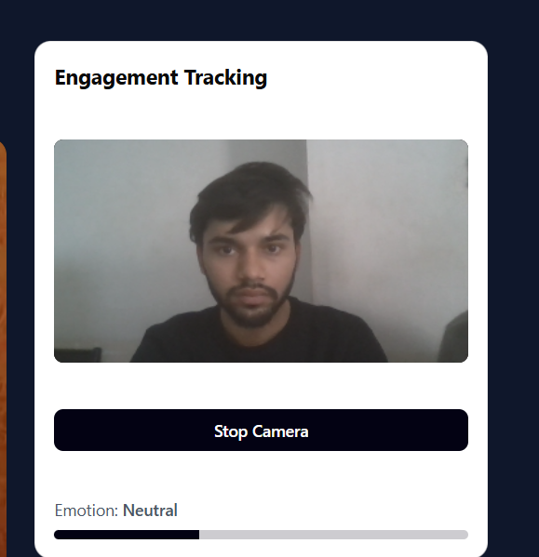

Fig 3.4.2.1 (Face recognition)

Emotion Recognition Module

Description:
This module identifies the emotional state of the user.

Implementation:
A Convolutional Neural Network (CNN) model and Deep-Face is used for emotion classification. The cropped face image is resized and normalized before being passed to the trained model. The model predicts emotions such as happy, stressed, neutral, or confused, and sends the result to the backend server.

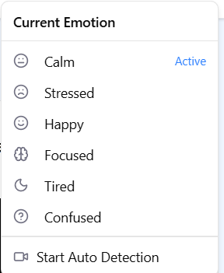

Fig – 3.4.3.1(Emotion Recognition)

Adaptive UI Module

Description:
This module modifies the interface based on detected emotions.

Implementation:
The backend processes the detected emotion and sends appropriate instructions to the frontend. Based on predefined rules:
- Confused → Display hints or explanations
- Tired → Show interactive content
- Happy → Change the background to orangish-yellow and buttons. React.js dynamically updates UI components without reloading the page.



Fig 3.4.4.1 (UI – focused) Fig- 3.4.4.2 (UI – Stressed)

Backend Processing Module Description:
This module manages system logic and communication between components.

Implementation:
Developed using Flask (Python), the backend handles API requests, processes emotion data, integrates the ML model, and sends responses to the frontend. It ensures smooth communication between UI and machine learning modules.

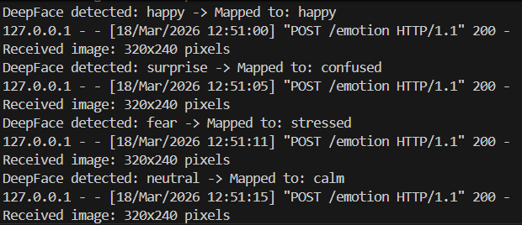

Fig – 3.4.5.1(Backend Processing)

Dashboard Module Description:
This module displays analytics related to user emotions and learning progress.

Implementation:
The dashboard is built using React.js and visualization libraries. It fetches stored emotion data from the backend and displays graphs such as emotion trends, engagement levels, and session history.

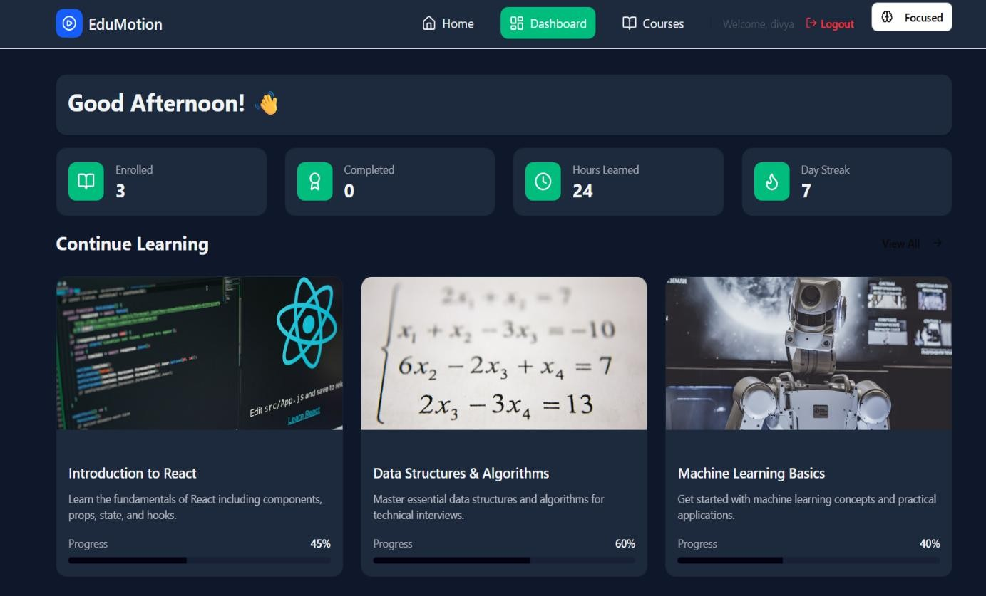
Fig 3.4.6.1(Dashboard)

Diagrams:

Use Case Diagram: Fig 3.5.1 represent the diagram that shows that how user interact the with the system.
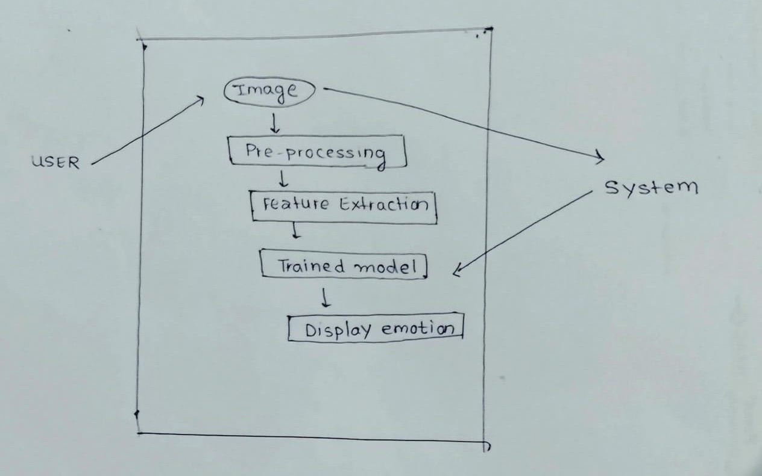

Fig – 3.5.1 (Use -Case Diagram)

E-R Diagram :

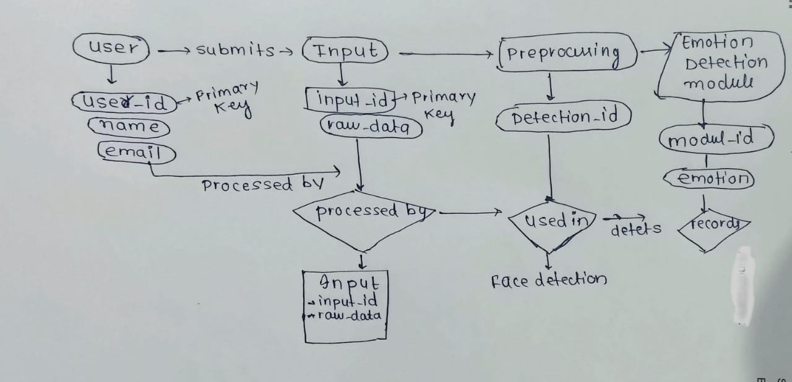

Fig -3.5.2 (Entity -Relation Diagram)

Data Flow Diagram:

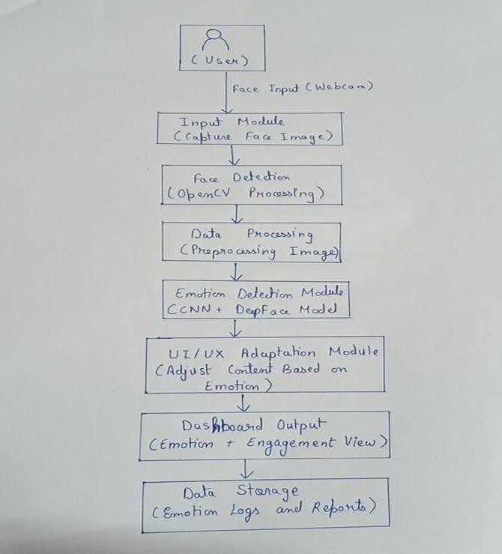

Fig – 3.5.3 (Data Flow Diagram)

CHAPTER IV SYSTEM REQUIREMENTS

Software Requirements
To ensure the UI/UX Adaptation via Face Emotion Recognition system runs efficiently and supports real-time emotion detection, the following software tools and technologies are required.

    - Operating System: The system can be developed and executed on Windows, Linux, or macOS.
    - Programming Language: Python (version 3.8 or higher) is used for backend development and machine learning implementation. A virtual environment (venv) is used for dependency management.
    - Web Server / Backend Framework: Flask is used to handle backend operations and API communication between frontend and machine learning modules.
    - Frontend Framework: React.js is used to build a responsive and interactive user interface.
    - Styling & UI: HTML, CSS, and JavaScript are used for designing the layout and improving user interaction.
    - Computer Vision Library: OpenCV is used for real-time face detection and image processing.
    - AI & Machine Learning Libraries: TensorFlow is used to develop and train the CNN model for emotion recognition.
    - Database: MongoDB is used to store user data, emotion tracking records, and system logs.
    - IDE / Development Tools: Visual Studio Code (VS Code) is used for coding, while Git and GitHub are used for version control and collaboration.
    - Client-Side Browser: Modern browsers such as Google Chrome, Mozilla Firefox, or Microsoft Edge are required for proper system performance.

Hardware Requirement

The hardware requirements are divided into client-side (user) and server-side (development/hosting) to ensure smooth functioning of the system.

For Client (User Side)
- Processor: A computer with an Intel i3 processor or higher (or an equivalent AMD processor) is recommended to smoothly run the responsive web interface.
- RAM: At least 4 GB of RAM is required, though 8 GB is recommended for better multitasking and smoother performance.
- Storage: Around 200 MB of free storage space is needed for browser cache and temporary data used during operation.
- Input Devices: A standard keyboard and mouse, or a touch-enabled screen, can be used to interact with the system.
- Internet Connection: A stable internet connection of at least 2 Mbps is required so the system can fetch real-time traffic, weather, and transit data.

For Server (Development / Hosting)
- Processor: A minimum Intel i5 processor or equivalent cloud computing instance is recommended to handle real-time data processing and backend operations.
- RAM: At least 8 GB of RAM is required to support API operations and machine learning model execution.
- Storage: A minimum of 20 GB storage is required, and using an SSD is highly recommended for faster data access and system performance.
- Cloud Infrastructure: The system can be hosted on cloud platforms such as Amazon Web Services (AWS) or Google Cloud Platform (GCP) to ensure high availability, scalability, and reliable performance.

CHAPTER V EXPECTED OUTCOMES
The UI/UX Adaptation via Face Emotion Recognition system is expected to create an intelligent and interactive learning platform that enhances user engagement through emotion-based personalization. Instead of providing a fixed interface to all users, the system dynamically adapts the learning environment based on the emotional state of the learner. This helps in improving understanding and maintaining user interest throughout the learning process.
One of the key outcomes of the project is real-time emotion detection using facial expressions captured through a webcam. The system will continuously analyze user emotions such as happy, stressed, confused, or tired and respond accordingly. This ensures that the learning platform becomes more responsive and supportive, reducing issues like confusion and lack of engagement during study sessions.
Another important outcome is the dynamic adaptation of the user interface. Based on detected emotions, the system will modify content presentation, such as providing hints when the user is confused, introducing interactive elements when the user is bored, or adjusting difficulty levels when the user is performing well. This leads to a more personalized and effective learning experience.
Additionally, the system will track and store emotional data over time, allowing the generation of analytical reports. These reports will help in understanding user behavior, engagement levels, and learning patterns. Such insights can be useful for both learners and educators to improve performance and learning strategies.
Overall, the proposed system aims to enhance the effectiveness of e-learning platforms by reducing user frustration, improving concentration, and providing a more engaging and adaptive learning environment.

CHAPTER VI CONCLUSION & FUTURE SCOPE
  - Conclusion
The UI/UX Adaptation via Face Emotion Recognition system addresses the key limitations of traditional e-learning platforms by introducing emotion-aware interaction into the learning process. Instead of providing a static interface, the system integrates real-time facial emotion recognition with adaptive UI techniques to create a more intelligent and responsive learning environment.
By using computer vision and deep learning models, the system is able to detect user emotions and dynamically adjust the interface based on the learner’s state. This reduces confusion, improves engagement, and enhances overall learning effectiveness. The integration of emotion detection with UI adaptation also minimizes the need for manual intervention, allowing learners to focus more on understanding content rather than struggling with it.
Overall, the system provides a seamless and personalized learning experience where the platform actively responds to user emotions, making digital education more interactive, efficient, and user-friendly.

  - Future Work
Although SynchroPlan successfully ful-fills its main objective of integrating scheduling with travel optimization, there are several opportunities for future improvements that can further enhance the system’s capabilities. One important development is advanced multi-source integration, where the platform could support more complex global travel needs such as flight tracking and automatic international time-zone management. Another potential enhancement is wearable device synchronization, allowing the system to connect with smartwatches and IoT devices to deliver haptic alerts for departure reminders or sudden transit changes. The platform could also introduce collaborative group logistics, enabling multiple users to coordinate schedules and find common free time slots despite different travel constraints. In addition, developing dedicated mobile and tablet applications for Android and iOS would allow users to manage their schedules more easily while on the move. Finally, predictive fatigue analysis could be implemented using machine learning to study a user’s travel patterns and recommend rest periods or buffer times, helping create a healthier and more balanced daily itinerary.

CHAPTER VII

REFERENCES

To maintain the "materialistic" and academic standard required for this project, the following references are specified:

Hadimlioglu, A., & Linga, S. (2025). FACE2FEEL: Emotion-Aware Adaptive User Interface. arXiv:2510.00489v1 [cs.HC]. (Foundation for emotion-driven adaptive UI design and case study on book recommendation).

Gaspar-Figueiredo, D., Abrahão, S., Fernández-Diego, M., & Insfran, E. (2025): Integrating Human Feedback into a Reinforcement Learning-Based Framework for Adaptive User Interfaces. arXiv:2504.20782v1 [cs.HC]. (Basis for RLHF in adaptive UI personalization).

Plintz, N., & Ifenthaler, D. (2023). Leveraging Emotions to Enhance Learning Success in Online Education: A Systematic Review. CELDA 2023. (Systematic review of affective computing in online learning environments).

Sheejamol, P. T., Tejat, G. C., Balaram, B., Rao, P. S., & Chacko, A. (2023). Mitr – Face Emotion Recognition Based Adaptive E-Learning Platform. IEEE WIECON-ECE 2023. (Assistive technology prototype for children with ASD using FER and emotion regulation).

Medjden, S., Ahmed, N., & Lataifeh, M. (2020). Adaptive User Interface Design and Analysis Using Emotion Recognition Through Facial Expressions and Body Posture from an RGB-D Sensor. PLOS ONE, 15(7): e0235908. (Multimodal emotion recognition with Kinect for adaptive UI).

Zaheer, S. (2023). Designing Emotion-Aware UX: Leveraging Sentiment Analysis to Adapt Digital Experiences. International Journal Research of Leading Publication (IJLRP), Vol. 4(8). (Explores multimodal sentiment analysis for adaptive UX, with ethical considerations in emotion-aware design).

Alipour, M., Moghaddam, M. T., Vaidhyanathan, K., & Kjærgaard, M. B. (2023). Emoticontrol: Emotions-based Control of User-Interfaces Adaptations. Proceedings of the ACM on Human-Computer Interaction, Vol. 7, Issue EICS. (Introduces Model-Free Reinforcement Learning for emotion-driven UI adaptation, tested in evacuation training).

Liu, Y., Tan, H., Cao, G., & Xu, Y. (2024). Enhancing User Engagement Through Adaptive UI/UX Design: A Study on Personalized Mobile App Interfaces. Computer Science & IT Research Journal, Vol. 5(8), pp.1942–1962. (Develops a context-aware adaptive UI/UX framework for mobile apps, validated via usability testing).

Mujiono, M., Wibowo, T. O., & Alvin, S. (2025). An Exploration of University Students’ Experience Using UI-UX Based E-Learning Platforms: Challenges and Recommendations. International Journal of Social Learning, Vol. 5(2), pp.322–336. (Qualitative study on UI/UX challenges in e-learning, highlighting accessibility and inclusivity issues).

Shou, Y., Meng, T., Ai, W., Fu, F., Yin, N., & Li, K. (2025). A Comprehensive Survey on Multi-modal Conversational Emotion Recognition with Deep Learning. Journal of the ACM, Vol. 37(4), Article 111. arXiv:2312.05735v2 [cs.AI]. (Provides a taxonomy of MCER methods—context-free, sequential context, speaker-differentiated, and speaker-relationship modeling—alongside datasets, feature extraction techniques, applications, and future directions).

